SWOT ANALYSIS

Approved Topic:
Development of Pet Registration and Monitoring System for Municipal Agriculture Office in Santa Cruz, Marinduque

Major Problem:
How the Municipal Agriculture Office of Santa Cruz, Marinduque can improve the efficiency, accuracy, and accessibility of animal registration, monitoring, and record-keeping through a webbased system that will help in responsible pet ownership, and local agricultural planning.

Specific Problems:
1. It is difficult to keep track of animal health records, vaccination history, and ownership information. 2. The local government lacks an updated list of registered animals, which affects planning, policymaking, and disease control.
3. When animals are lost or unregistered, it is difficult to trace them, which can cause problems in the community.

A. STRENGTHS (S) B. WEAKNESSES (W)
1. Faster registration process for 1. Needs stable internet INTERNAL pet owners. connection to function well.
FACTORS 2. Centralized database for 2. Staff must learn how to use the storing complete pet information. system.
- Reduces manual errors in 3. Some pet owners may find recording. online registration challenging.
- Allows quick searching and 4. Technical issues may happen updating of records. (bugs, downtime).
- System is accessible online 5. Data entry mistakes can still anytime. happen if done carelessly.
EXTERNAL 6. Helps monitor vaccination 6. Needs regular backups to avoid
FACTORS schedules. losing information.
7. Keeps digital copies of pet 7. Some users may still prefer documents. manual registration.
C. OPPORTUNITIES (O) | E.1. SO Strategies | E.2. WO Strategies
1. Improve pet monitoring within the municipality. | 1. Use the centralized database to improve pet monitoring in the whole municipality. | 1. Give proper pet ownership guidelines to teach owners how to register online.
2. Future add-on for SMS reminders for vaccination schedules. | 2. Use the online system to help increase awareness about responsible pet ownership. | 2. Work with veterinary clinics to train staff on how to properly record pet information in the system.
3. Increase awareness of responsible pet ownership. | 3. Use the fast search and update features to support barangay-level monitoring in the future. | 3. Use barangay-level expansion to help pet owners who find online registration difficult.
4.Expand system to include barangay-level monitoring. | 4.Connect the vaccination monitoring feature with future SMS reminders. | 4. Use planning and decisionmaking data to support regular system backups.
5.Possible partnership with veterinary clinics. | 5. Use digital pet records to build partnerships with veterinary clinics. | 5. Use SMS reminders to reduce mistakes in vaccination updates.
6. Can be used as data for decision-making and planning. | 6. Use the system’s online access to support future pet adoption services. | 6. Use the convenient online process to encourage owners to shift from manual to online registration.
7. Future expansion to include pet adoption services. | 7. Reduce manual errors so the system can provide accurate data for planning and decisions. | 7. Use community awareness programs to reduce the number of pet owners unwilling to register.

D. THREATS(T) | E.3. ST Strategies | E.4. WT Strategies
1. Cybersecurity risks like hacking or data leaks. | 1. Use digital copies of records to create safe backups and protect against hacking or data loss. | 1. Train staff well to prevent mistakes that may cause system problems.
2. Slow or unstable internet in some barangays. | 2. Use the centralized database to keep records updated even if some barangays have slow internet. | 2. Create an offline registration option for barangays with unstable internet.
3. Pet owners unwilling to register their pets. | 3. Use the faster registration process to encourage owners who do not want to register. | 3. Provide simple guides to help owners who are unsure about registering online.
4. Budget cuts affecting system maintenance. | 4. Use the vaccination monitoring feature to support requests for continuous system funding. | 4. Do regular security checks to prevent hacking and data leaks.
5. Technical failures that may cause temporary system downtime. | 5. Use the digital record to restore information quickly during downtime. | 5. Set up local backup storage to keep information safe during technical failures.
 | 6. Reduce human errors to prevent problems that result from incorrect data. | 6. Fix system issues quickly to avoid long downtime periods.
 |  | 7. Offer help through barangays to reduce the number of owners who refuse to register their pets.

INTERVIEW RESULTS

A. Strengths
- Registration becomes faster.
- Centralized database helps organize records.
- Fewer manual errors.
- Easier searching and updating.
- Accessible online anytime.
- Helpful for monitoring vaccinations.
- Digital copies keep documents safe.

B. Weaknesses
- Needs stable internet.
- Staff need training.
- Some owners may find online use difficult.
- Possible technical issues.
- Errors still possible if careless.
- Requires regular backups.
- Some still prefer manual registration.

C. Opportunities
- Better pet monitoring.
- Possible SMS reminders.
- Promotes responsible pet ownership.
- Can expand to barangays.
- Can partner with veterinarian clinics.
- Useful for planning and decisions.
- Can add pet adoption features.

D. Threats
- Risk of hacking or data leaks.
- Slow internet in some barangays.
- Owners may refuse to register.
- Technical failures may interrupt service.
- Downtime may affect office operations.

E. Strategies E.1. – SO Strategies
- Use the centralized database to enhance pet monitoring across the entire municipality.
- Use the online system’s accessibility to help promote responsible pet ownership.
- Use fast search and update features to support future barangay-level monitoring.
- Connect the vaccination monitoring feature with future SMS reminders.
- Use digital pet records to help build partnerships with veterinary clinics.

E.2. – WO Strategies
- Provide guidelines and orientations to help pet owners register online.
- Partner with veterinary clinics to assist in training staff on correct data entry.
- Use barangay-level expansion to assist owners who struggle with online registration.
- Use data gathered for decision-making to justify regular system backups.
- Use SMS reminders to help reduce mistakes in updating vaccination records.

E.3. – ST Strategies
- Use digital copies of records to create secure backups and reduce risks from hacking or data loss.
- Use the centralized database to keep records updated even in areas with slow internet.
- Use the fast registration process to encourage pet owners who are hesitant to register.
- Use vaccination monitoring data to support continuous funding for system maintenance.
- Use digital documentation to restore information quickly during system downtime.

E.4. – WT Strategies
- Provide proper training for staff to avoid errors that may cause system issues.
- Develop an offline registration option for areas with unstable internet.
- Provide simple user guides to help owners understand online registration.
- Conduct regular system security checks to prevent hacking and data leaks.
- Set up local backup storage and fix system issues quickly to avoid prolonged downtime.

F. Remarks
The strategies presented align with the strengths, weaknesses, opportunities, and threats identified through the interview and SWOT analysis. These strategies aim to ensure the system’s efficiency, security, accessibility, and long-term sustainability while addressing challenges such as internet limitations, user adaptation, technical risks, and data management concerns. In general, the combined strategies support the successful implementation and future improvement of the web-based pet registration and monitoring system.

Prepared by:

RUBY CHARLENE PERILLA

DAD’S CHARLOTTE PRIVADO

Date:

PROJECT DESCRIPTION (Option No. 1)

Characteristics:
- Provides a centralized database for storing pet and owner information.
- Uses an online platform accessible through computers or mobile devices.
- Allows real-time updates on vaccinations, registration, and pet status.
- Generates automated reports for monitoring and planning.
- Supports secure user access for authorized personnel.
- Designed with a user-friendly interface for easy navigation.

Advantages:
- Improves accuracy and organization of pet records.
- Speeds up registration and monitoring processes.
- Reduces manual tasks and paperwork.
- Allows quick searching and retrieval of important information.
- Helps track vaccination schedules and pet ownership compliance.
- Enhances transparency and supports responsible pet ownership.

Disadvantages:
- Requires stable internet access to function properly.
- Some staff or users may need training to use the system.
- System maintenance may require regular updates.
- Technical issues may temporarily affect operations.
- Slow network speeds can affect system responsiveness.
- Some pet owners may not fully participate in the digital process.

Major Parts | Functions
Registration Section | Handles the recording and updating of pet and owner information.
User Interface | Provides an easy-to-use screen layout where staff and users can navigate the system smoothy.
Security System | Protects data, manage access, and prevents unauthorized usage.
Monitoring Section | Keeps track of vaccination schedules, reminders and pet status.
Search & Retrieve Area | Allows quick searching and viewing of stored records using filters or keywords.
User Management Area | Manage user accounts, access permissions, and account changes

Prepared by:

RUBY CHARLENE PERILLA

DAD’S CHARLOTTE PRIVADO

Date:

CHAPTER I INTRODUCTION

BACKGROUND OF THE STUDY
Proper record-keeping for pets is important for responsible ownership, animal welfare, and public safety. Many local communities need accurate and updated information to monitor vaccinations, identify pets, and manage the growing number of pets. Although an existing system is already being used, it still has several limitations that make record-keeping slow, incomplete, and difficult to manage. Therefore, local offices encounter challenges in maintaining accurate, organized, and readily accessible information. In Santa Cruz, Marinduque, the Municipal Agriculture Office (MAO) is responsible for registering pets and monitoring their health and ownership records. Despite their efforts, the office still faces difficulties in keeping track of vaccination history, health information, and updated lists of registered animals. The current system has limitations that make some records incomplete, outdated, or difficult to retrieve. As a result, the MAO encounters challenges in planning, monitoring, and maintaining community safety, especially when unregistered or lost animals cannot be easily identified.

The main problem of this study is how the Municipal Agriculture Office of Santa Cruz, Marinduque
can improve the efficiency, accuracy, and accessibility of animal registration, monitoring, and record-keeping through a system that supports responsible pet ownership and local agricultural planning. Based on an interview with the Municipal Agriculturist, the office has difficulty tracking pet information because records are stored through traditional, paper-based documentation, which makes it challenging to consolidate and update information quickly. Vaccination updates are not always properly recorded, files sometimes go missing, and tracing unregistered animals is challenging. These problems indicate that the municipality needs a more effective and organized system to manage the increasing number of pets. The problem is caused by several factors such as increasing number of animals without a proper tracking system, the limited tools available for monitoring pet records, and the lack of awareness among some owners about the importance of registering their pets. These issues lead to slow services, difficulty monitoring animal health and vaccinations, and risks caused by unregistered pets that cannot be easily identified during conflicts, losses, or emergencies. To address these concerns, the study proposes creating a Pet Registration and Monitoring System for Santa Cruz, Marinduque. This system will act as a centralized, easy-to-access platform where the MAO, veterinarians, and pet owners can record, update, and retrieve important information. Through this approach, the municipality can enhance data accuracy, streamline services, strengthen animal welfare initiatives, and ensure safer and more efficient management of pets within the community.

OBJECTIVES OF THE STUDY
General Objective:
The general objective of this study is to develop a pet registration and monitoring system that will improve efficiency, accessibility, and accuracy in managing animal records in Santa Cruz, Marinduque.

Specific Objectives:
This study has the following specific objectives:
- To develop a system that improves the process of recording and maintaining pet health, vaccination, and ownership information.
- To create an organized and updated database of all registered pets to enhance the Municipal Agriculture Office’s planning and monitoring activities.
- To design a feature that enables efficient tracking of lost and unregistered pets to promote responsible pet ownership and community safety.

SCOPE AND LIMITATIONS OF THE STUDY
The scope of this study is to design and develop a web-based Pet Registration and Monitoring System intended for use by the Municipal Agriculture Office (MAO) of Santa Cruz, Marinduque. The system focuses on organizing and managing pet information, owner records, vaccination data, and monitoring updates. It is designed exclusively for MAO administrators and staff, who will be responsible for encoding, updating, and retrieving pet-related information. The study covers system analysis, database design, system development, and testing to ensure that the application functions according to the identified requirements.

On the other hand, it is important to acknowledge certain limitations. The system is specifically
developed for Santa Cruz, Marinduque, and does not include other municipalities or any form of provincial or national implementation. Its functionality is limited to registration, record management, and monitoring, and does not include advanced features such as automated health assessments, GIS-based location tracking, and integration with national pet registries and veterinary clinics. Furthermore, the system requires a stable internet connection for proper use. Therefore, users in areas with poor or no internet access may experience difficulties in accessing the system.

SIGNIFICANCE OF THE STUDY
This study is significant as it aims to enhance the management of pet registration and monitoring in Santa Cruz, Marinduque through a web-based system that provides accurate records, improved tracking of vaccination data, and organized monitoring of pet information. By developing this system, the Municipal Agriculture Office (MAO) can make work easier, reduce errors, and ensure that pet records are properly documented and easily retrievable. This contributes to more efficient operations and supports the municipality’s efforts in maintaining animal welfare, public safety, and responsible pet management. The proposed system could be beneficial to the following:

To the Municipal Agriculture Office (MAO):
A pet registration and monitoring system provides MAO staff with an efficient and organized method for registering, monitoring, and updating pet records in a centralized database.

To the Local Government Unit (LGU):
A pet registration and monitoring system offers reliable and organized data on pet populations and vaccination coverage to support policy-making, animal control programs, and public safety initiatives.

To the Pet Owners:
A pet registration and monitoring system allows pet owners to ensure that their pets’ records and vaccination histories are accurately maintained and properly monitored by the MAO.

To the Community:
A pet registration and monitoring system contributes to a safer and healthier environment by improving the monitoring of pets and reducing risks associated with unregistered or unmonitored animals.
To the Developers:
The development of this system provides an opportunity for the developers to enhance their skills in database design, system analysis, and web-based application development.

To Future Researchers:
This study serves as a reference for future studies aiming to develop or improve digital systems for pet registration and monitoring.

CHAPTER II CONCEPTUAL FRAMEWORK

This chapter presents the review of related literature and studies underlying the framework of the study.
It includes the conceptual model of the study and the operational definition of terms.

REVIEW OF RELATED LITERATURE AND STUDIES Introduction

Cats and dogs are increasingly considered as important members of households, and pet ownership has increased in importance across human society. The necessity for efficient health management and monitoring systems has been highlighted with an increase in pet populations. The KelPet system was created in Ghana to fill in the gaps in pet healthcare accessibility, especially at a time when many pet owners found it difficult to keep an eye on their animals or get them to veterinary clinics. The system comprises of a smart pet collar that can detect heart rate, temperature, activity levels, and GPS position. It also includes a mobile application that shows the locations of nearby veterinary hospitals, gives owners advice on how to contact veterinarians, and notifies owners of changes in their health. The system can monitor multiple pets per owner and is cost-effective, offering a practical solution to address the challenges of high importation fees and limited access to sophisticated health monitoring systems in Africa [1].

Technological developments in digital monitoring have made it possible to track pets in real time and
regulate their health. Pet owners can remotely keep an eye on their pets' location and health with the use of GPS and SMS-based monitoring systems, microcontrollers, and temperature sensors [2]. Similarly, vaccine monitoring and animal record-keeping have been simplified by RFID-based systems like the Animal Identification and Records Monitoring Tool (AIRMTR), which has decreased errors from manual processes. By facilitating online scheduling and identification, these technologies enhance overall animal care while providing doctors and pet owners with greater convenience and accuracy [3].

Understanding local pet populations is essential for planning vaccination campaigns and managing
public health risks, such as rabies. A study conducted in multiple areas of the Philippines surveyed households to estimate dog population densities across urban, semi-urban, rural, and small island communities. The findings revealed variations in human-to-dog ratios, which were subsequently used to adjust anti-rabies vaccination strategies. These interventions led to significant increases in vaccination coverage in selected locations, highlighting the importance of population-specific data for effective health program implementation [4]. Similarly, public opinion research in Malaysia found that respondents attributed stray animal populations to insufficient awareness of proper animal care, while many supported vaccination and treatment of animals exposed to zoonotic diseases. Multi-stakeholder strategies, including the development of animal protection areas, received strong public support, underscoring the role of societal participation in responsible pet and stray management [5].

The overpopulation of stray dogs remains a persistent global challenge, with unregulated reproduction
contributing to health risks, public safety issues, and environmental concerns. Effective management requires an integrated approach involving legal enforcement, public education, vaccination, sterilization, and digital tracking systems to reduce the risks associated with stray populations [6].

Global studies on dog population management demonstrate that unmanaged populations of free-
roaming dogs present significant public health risks, including zoonotic disease transmission, road accidents, and environmental impacts. Systematic interventions, combining sterilization programs, vaccination campaigns, and community education, have been shown to effectively reduce these risks. A systematic review of dog population management practices highlighted the effectiveness of methods such as trap-neuter-return (TNR) programs, vaccination, and population monitoring when integrated with community involvement [7]. Likewise, monitoring schemes for free-roaming cats have utilized citizen science to gather reliable population data, enabling local authorities to implement humane and sustainable control programs [8].

Compliance with legal frameworks significantly affects the success of pet health programs. In Magalang, Pampanga, Philippines, many pet owners were unaware of RA 9482, the Anti-Rabies Act of 2007, and demonstrated poor knowledge of its requirements. This lack of awareness points to the critical need for educational campaigns, digital monitoring systems, and simplified registration processes to improve participation in vaccination programs and promote responsible pet ownership [9]. Regulatory gaps in purebred dog and cat management have also been noted. Legal definitions for purebred animals traditionally apply to livestock, leaving companion animals vulnerable to unregulated breeding practices that can compromise health and enable fraudulent pedigrees. Advocates have proposed extending binding legal frameworks to cover purebred companion animals, thereby enhancing welfare and traceability across Europe [10].

In the European Union, companion animals are increasingly recognized as moral subjects and valued
as family members. Despite this societal shift, significant gaps remain in the legislation regulating dog and cat welfare. Current EU legislation does not adequately address unhealthy breeding practices, irresponsible ownership, transport for commercial and non-commercial purposes, training methods, working dog conditions, shelter management, and management of free-ranging cats. Research emphasizes that education, awareness, and stakeholder involvement, guided by a transdisciplinary One Welfare approach, are critical for enhancing animal welfare standards and bridging gaps in existing legal frameworks [11].

The integration of web-based and mobile technologies has further enhanced rabies control and pet
management. In Thailand, risk-driven spatial-epidemic models were incorporated into user-friendly web and mobile applications to optimize vaccination efforts around rabies outbreak zones. These applications combine dog movement analyses with disease transmission simulations, enabling authorities to customize vaccination radii, improve resource allocation, and achieve better control outcomes compared to fixed-radius approaches [12]. Animal health monitoring systems that combine behavioral information with physiological measurements, such as heart rate and activity level, allow for more accurate detection of anomalies and early warning of health risks. Systems employing video image analysis and mask R-CNN feature extraction have successfully monitored both typical and unusual behaviors in laboratory animals, demonstrating potential applications in domestic pet monitoring [13].

Pet care mobile applications and tracking systems, such as those developed in India, facilitate realtime monitoring and communication with pet owners. These systems allow for continuous updates on pets’ health and safety, enabling timely interventions even when owners are not physically present [14]. Community engagement has been identified as a critical factor in managing free-roaming cat populations. Systematic reviews show that programs combining education, adoption, and trapping yield the most effective reductions in cat populations, demonstrating that human behavioral factors significantly influence intervention outcomes [15].
National-level programs, such as Chile’s National Dog Population Management Program, illustrate
the importance of combining identification, sterilization, vaccination, and public education to mitigate humananimal conflicts. Data-driven interventions, tailored to local conditions and guided by human-to-dog ratios, improve program effectiveness and resource allocation. The program further recommends baseline data collection, localized population estimates, and sustainable public education initiatives to enhance long-term outcomes [16]. Provincial-level monitoring systems, such as in Laguna, Philippines, integrate data from veterinary offices with geospatial analysis to visualize disease distribution, identify high-risk areas, and guide intervention measures. Mapping annual case reports and overlaying spatial layers of geographic features allow authorities to make informed decisions regarding resource allocation and outbreak control [17].

Digital reservation and care management systems, like the Pet Care Management System, automate
previously manual processes, reducing human errors, saving time, and enabling paperless environments. Such systems are particularly valuable in pet service centers, where accurate record-keeping and timely interventions are critical [18]. Advanced image registration techniques, originally used in medical applications, have been adapted to monitor pets’ physiological data accurately, ensuring precise tracking and effective response to health anomalies [19].

In the United States, community-based veterinarian initiatives provide underprivileged people easily accessible care, proving that cultural knowledge, empathy, and communication are essential components of effective interventions. These initiatives improve overall wellbeing and owner satisfaction by ensuring that pets' access to essential medical care is not limited by budgetary limitations [20]. Similarly, community sterilization programs in rural Australia have effectively reduced the number of cats entering shelters, lowered euthanasia rates, and decreased complaints related to free-roaming cats, showcasing the value of humane, community-aligned population control measures [21].

Synthesis
The reviewed literature emphasize the increasing significance of pets within communities and the need for effective health management, monitoring, and population control strategies. Evidence indicates that comprehensive understanding of local pet populations, active community engagement, and targeted public education are essential for the successful implementation of health programs, particularly in the control of rabies and management of free-roaming animals. Moreover, adherence to legal frameworks and regulatory compliance plays a critical role in the success of pet health and welfare initiatives. Integrated approaches, including sterilization, vaccination, population monitoring, and humane management practices, have demonstrated global effectiveness. These findings suggest that sustainable improvements in pet health management and responsible ownership depend on the combined efforts of communities and the enforcement of supportive legal measures.

REFERENCES

- Jacinta, H. 2024. [Online]. Design of health monitoring and analysis system for pets (cats) - KelPet.
Available: https://air.ashesi.edu.gh/items/6d32d853-51a0-4e55-a599-ecb142e3902a

- Saputra, K. Kamelia, L. and Zaki E A. 2021. [Online]. Integration of animal tracking and health monitoring systems
Available: https://iopscience.iop.org/article/10.1088/1757-899X/1098/4/042075/meta

- Dipay J M B. Fabregas, A C. and Ado, R G. 2018. [Online]. Animal Identification and Records
Monitoring Tool using RFID (AIRMTR). Available: https://kneopen.com/kne-social/article/view/2415/

- Chaudhari, A. Kartal, T. Brill, G. Amano, K J. Lagayan, M. and Jorca, M. 2022. [Online].
Dog Ecology and Demographics in Several Areas in the Philippines and Its Application to Anti-Rabies Vaccination Programs. Available: https://www.mdpi.com/2076-2615/12/1/105

- Munir, S. Mokhtar M. and Arham A. 2023. [Online]. Public perspectives on strays and companion animal management in Malaysia. Available: https://link.springer.com/article/10.1186/s12889-023-16276-5

- Dizon, T. and Saito, N. 2022. [Online]. Household survey on owned dog population and rabies knowledge in selected municipalities in Bulacan, Philippines: A cross-sectional study. Available:
https://journals.plos.org/plosntds/article?id=10.1371/journal.pntd.0009948

- Smith, L. Hartmann, S. Munteanu, A. Villa, P. Quinnell, R. and Collin, L. 2019. [Online]. The Effectiveness of Dog Population Management: A Systematic Review. Available:
https://www.mdpi.com/2076-2615/9/12/1020

- Gunther, I. Azriel, L. Wolf, H. Raz, T. and Klement, E. 2020 [Online]. An accessible scheme for monitoring free‐roaming cat population trends. Ecology and Evolution. Available:
https://onlinelibrary.wiley.com/doi/full/10.1002/ece3.5982

[9]San Jose, R. Magsino, P. and Bundalian, R. 2019. [Online]. Pet owners' awareness on RA 9482 (AntiRabies Act of 2007) in Magalang, Pampanga Philippines. Heliyon. Available:
https://www.cell.com/heliyon/fulltext/S2405-8440(19)31509-9

- Contalbrigo, L. Normando, S. Bassan, E. and Mutinelli, F. 2024. [Online]. The Welfare of Dogs and Cats in the European Union: A Gap Analysis of the Current Legal Framework. Available:
https://www.mdpi.com/2076-2615/14/17/2571

- Fossati, P. and Ruffo, G. 2021. [Online]. Purebred dogs and cats: A proposal for a better protection.
Available: https://www.sciencedirect.com/science/article/abs/pii/S1558787821000587

- Thanapongtharm, W. Youngjitikornkun, C. Wannakee, H. and Wiratsudakul, A. 2025. [Online].
Development and application of web-based and mobile tools for risk-driven rabies control in Thailand. Available: https://www.sciencedirect.com/science/article/pii/S2352771425001144

- Shibanoki, T. Yamazaki, Y. and Tonooka, H. 2024. [Online]. A System for Monitoring Animals Based on Behavioral Information and Internal State Information. Available: https://www.mdpi.com/20762615/14/2/281

- Lambert, A. Gowtham, Jk. Prasath R. and Krishanan H. 2023. [Online]. Design and Implementation of a Pet Care and Tracking System. IEEE Xplore. Available: https://ieeexplore.ieee.org/abstract/document/10142399

- Riveros, D. and Lagos. C. 2024. [Online]. Community Engagement and the Effectiveness of Free-
Roaming Cat Control Techniques: A Systematic Review. Available: https://www.mdpi.com/20762615/14/3/492

- Garde, E. Vial, P. Perez, G. and Sandvig, E. 2022. [Online]. A Review and Analysis of the National Dog
Population Management Program in Chile. Available: https://www.mdpi.com/2076-2615/12/3/228

- Andres, P. and Repalam, M. C. 2025. [Online]. Provincial animal health monitoring system and geospatial analysis in the Province of Laguna. Available: https://pubs.aip.org/aip/acp/articleabstract/3287/1/030001/3341970/Provincial-animal-health-monitoring-system-and

- Yeow, J. and Kamaludin, H. 2023. [Online]. Pet Care Management System. Available:
https://publisher.uthm.edu.my/periodicals/index.php/aitcs/article/view/11969

- Yuen, J. Poder, J. Jameson, and M. Schmidt, L. 2024. [Online]. Improving patient specific quality assurance for image registration: clinical use case of target contouring for PET deformable image registration. Available: https://link.springer.com/article/10.1007/s13246-025-01541-1

- Kogan, L. Accornero, V. Gelb, E. and Slater, M. 2021. [Online]. Community Veterinary Medicine Programs: Pet Owners' Perceptions and Experiences. Available:
https://www.frontiersin.org/journals/veterinary-science/articles/10.3389/fvets.2021.678595/full

- Rand, J. Saraswathy, A. Verrinder, and J. Paterson, M. 2024. Outcomes of a Community Cat Program Based on Sterilization of Owned, Semi-Owned and Unowned Cats in a Small Rural Town. [Online]. Available: https://www.mdpi.com/2076-2615/14/21/3058

CONCEPTUAL MODEL OF THE STUDY
On the basis of the foregoing concepts, theories, and findings of related literature, studies presented, and insights taken from them, a conceptual model is developed as shown below:
Inputs Process Output
Knowledge Requirements

a.
Understanding how pet
registration works

b.
Basic
knowledge
of
database management

c. Knowledge of web or
system development

d. Familiarity with user needs
in the Municipal Agriculture
Office

e. Knowledge of data privacy
and record
-
keeping rules

Software Requirements

a. Web browser

b. Database software

c. Programming tools

d. Operating system

e. Web server software

Hardware Requirements

a.
Desktop or laptop computer

b. Stable internet connection

c. Server or computer for
hosting the system

d. Storage device for saving
data

e. Printer for printing reports
or certificates

Design

a.
Identify system features needed
by the Municipal Agriculture
Office

b. Create the layout of the user
interface

c. Plan the database structure for
storing pet and owner information

d. Organize the workflow for
registration, monitoring, and
reporting

e. Prepare system diagrams to
guide development

Development

a.
up
the
development
Set
required
environment
and
software

b. Build the database for pet,
owner, and vaccination records

c. Develop the main system
modules

d. Connect the interface with the
database

e. Integrate all functions into one
working system

Testing and Improvements

a. Check each feature to ensure it
works correctly

b.
Identify bugs or errors in the
system

c.
Ask users or evaluators for
feedback

d.
Fix problems and adjust
features based on feedback

e.
Improve
system
speed,
accuracy, and usability

A

working Pet Registration
and Monitoring System that
records pet and owner
information,

tracks
vaccinations, and organizes
all data in one place. The
system helps staff manage
records faster and easier, and
it can also generate reports
when needed.

Evaluation

a.
Check if the system works properly and
performs all required functions

b.
Gather feedback from users to see if the
system is easy to use

c.
Review the system’s accuracy, speed,
and reliability for improvements

Figure 2. The conceptual model of the study.

The conceptual model explains how the Pet Registration and Monitoring System is created and
improved. It starts with the inputs, which include the needed knowledge, software, and hardware to build the system. Then it goes through the process, where the system is designed, developed, tested, and improved to make sure everything works well. After completing these steps, the output is a working system that can record pet information, track vaccinations, and help the Municipal Agriculture Office manage pet records more easily. The evaluation step checks if the system is useful, easy to use, and meets the needs of the staff and the community.

OPERATIONAL DEFINITION OF TERMS
To ensure clarity and avoid misunderstanding, the following terms are defined based on how they are
used in this study:

Pet Registration. The process of entering and saving a pet’s information and its owner’s details into the system.
Monitoring. Tracking a pet’s status, vaccination updates, and other important records through the system. Municipal Agriculture Office (MAO). The office in Santa Cruz, Marinduque responsible for managing pet records and using the system.
Santa Cruz, Marinduque. The municipality where the system will be used and where the MAO manages pet registration and monitoring.
Vaccination Record. The information stored in the system showing the vaccines a pet has received, along with the dates they were given.
Owner Profile. The stored details about a pet owner, including name, address, and contact number.
Pet Profile. The complete information of a pet, such as its name, breed, age, type, and health status. Pet. In this study, it refers to any domesticated animal owned by a resident, such as dogs or cats, whose information is recorded and monitored in the system.
System. Refers to the Pet Registration and Monitoring System developed in this study to help record, track, and organize pet information.

WORKING DRAWINGS

Use Case Diagram

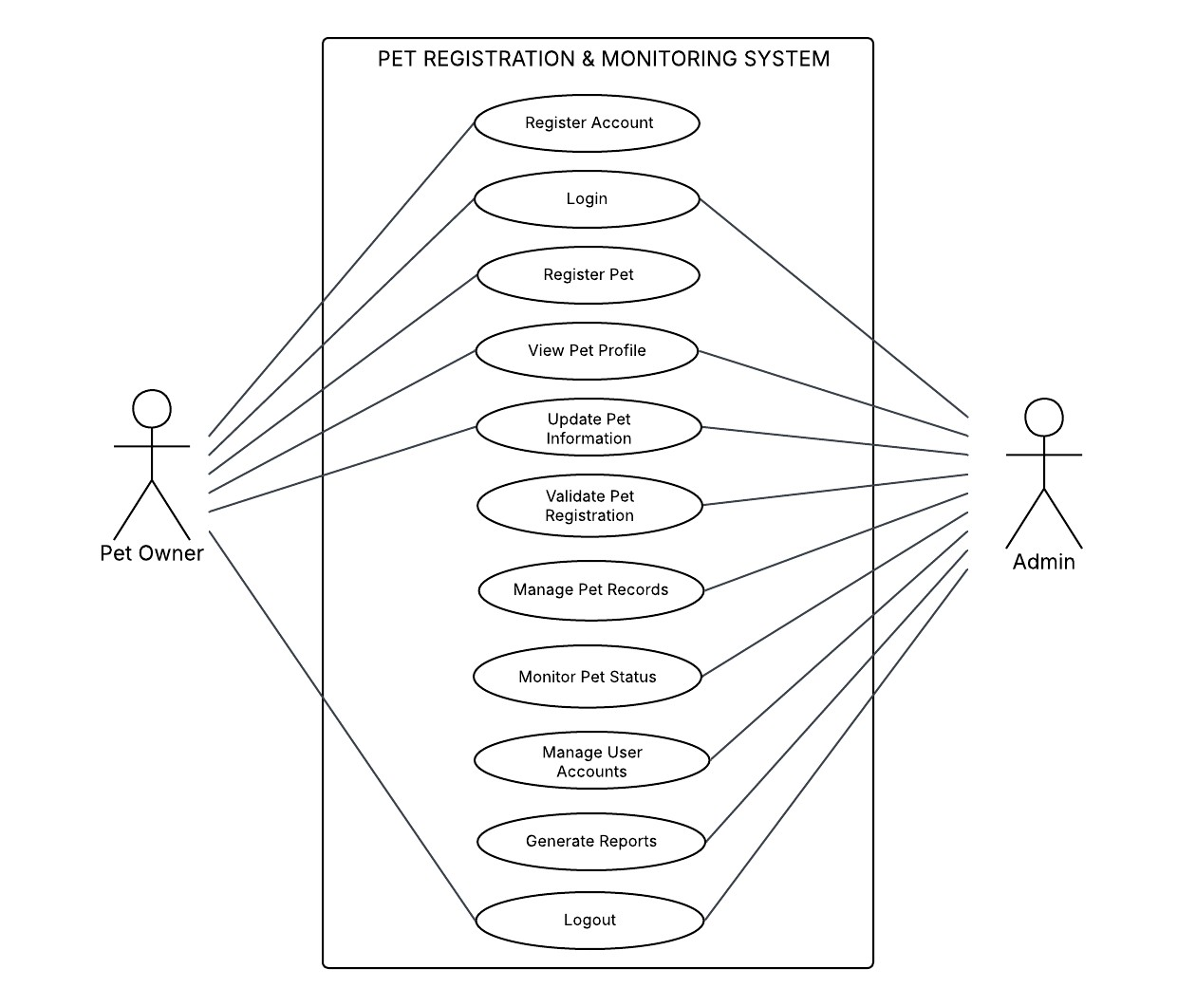

Use Case Title | Register Account
Primary Actor: | Pet Owner
Description: | Creating a new user account.
Goal: | To allow the Pet Owner to access the system.
Normal Scenarios: | - The Pet Owner enters all required information.  - The system saves the new account.

Use Case Title | Login
Primary Actor: | Pet Owner and Admin
Description: | User enters login details.
Goal: | To give access to the user dashboard.
Normal Scenarios: | - The user enters correct login details and the system grants access.  - The user enters incorrect details and the system shows an error.

Use Case Title | Register Pet
Primary Actor: | Pet Owner
Description: | Adding a pet’s information.
Goal: | To officially register the pet in the system.
Normal Scenarios: | - The Pet Owner inputs complete pet details.  - The system saves the pet registration.

Use Case Title | View Pet Profile
Primary Actor: | Pet Owner and Admin
Description: | Viewing the pet’s information.
Goal: | To allow the Pet Owner to see pet details.
Normal Scenarios: | - The Pet Owner selects the pet profile and the system displays it.  - The system shows the updated information if changes were made.

Use Case Title | Update Pet Information
Primary Actor: | Pet Owner and Admin
Description: | Editing pet details.
Goal: | To keep pet information updated.
Normal Scenarios: | - The Pet Owner and Admin updates pet details and the system saves the changes.  - The system shows an error if the entered details are invalid.

Use Case Title | Validate Pet Registration
Primary Actor: | Admin
Description: | Checking and approving pet registrations.
Goal: | To ensure pet details are correct before approval.
Normal Scenarios: | - The Admin reviews the registration and approves it.  - The Admin sees missing information and requests updates.
Use Case Title | Manage Pet Records
Primary Actor: | Admin
Description: | Organizing and editing pet records.
Goal: | To maintain complete and accurate pet records.
Normal Scenarios: | - The Admin updates a pet record.  - The Admin deletes incorrect or duplicate records.

Use Case Title | Monitor Pet Status
Primary Actor: | Admin
Description: | Checking health and vaccination status.
Goal: | To ensure pets are properly monitored.
Normal Scenarios: | - The Admin reviews the pet’s vaccination status.  - The Admin requests updates if information is incomplete.

Use Case Title | Manage User Accounts
Primary Actor: | Admin
Description: | Updating and maintaining user accounts.
Goal: | To ensure secure and active user access.
Normal Scenarios: | - The Admin updates user details or account status.  - The Admin deactivates accounts that violate system rules.

Use Case Title | Generate Reports
Primary Actor: | Admin
Description: | Creating system reports.
Goal: | To provide information for monitoring and decision-making.
Normal Scenarios: | - The Admin selects a report type and the system generates it.  - The Admin applies filters and the system updates the report.

Use Case Title | Logout
Primary Actor: | Pet Owner and Admin
Description: | Exiting the system.
Goal: | To safely end the user session.
Normal Scenarios: | - The Pet Owner and Admin clicks “Logout” and the system returns to the login screen.  - The system logs out the user after inactivity.

WORK BREAKDOWN STRUCTURE

1. Initiating Process
1.1 Formulation of Team
1.2 Selection of Organization
1.3 Selection of Potential Project
1.4 Submission of a Letter to the Adviser
1.5 Submission of a Letter to the Organization
1.6 Preparation of the Project Schedule

2. Planning Process
2.1 Identifying the Scope and Limitation
2.2 Determining the Significance of the Study
2.3 Reading and Gathering Related Literature and Studies
2.4 Determining the tools and techniques to be used
2.5 Identifying the Hardware and Software Requirements

2.6 Feasibility Study
2.6.1 Technical Feasibility
2.6.2 Operational Feasibility 2.6.3 Economic Feasibility

2.7 Use Case Model of the developed system
2.8 Entity Relationship Diagram of the developed system
2.9 Work Breakdown Structure and Gantt chart

3. Executing Process
3.1 Agile Model as the Methodology
3.2 Coding
3.3 System Testing
3.4 Implementation and Unit Testing

4. Monitoring and Controlling Process
4.1 Finalizing the Documentation
4.2 Monitoring of errors in the system
4.3 Determining syntax and logical errors

5. Closing Process
5.1 Maintenance
5.2 Installation

GANTT CHART
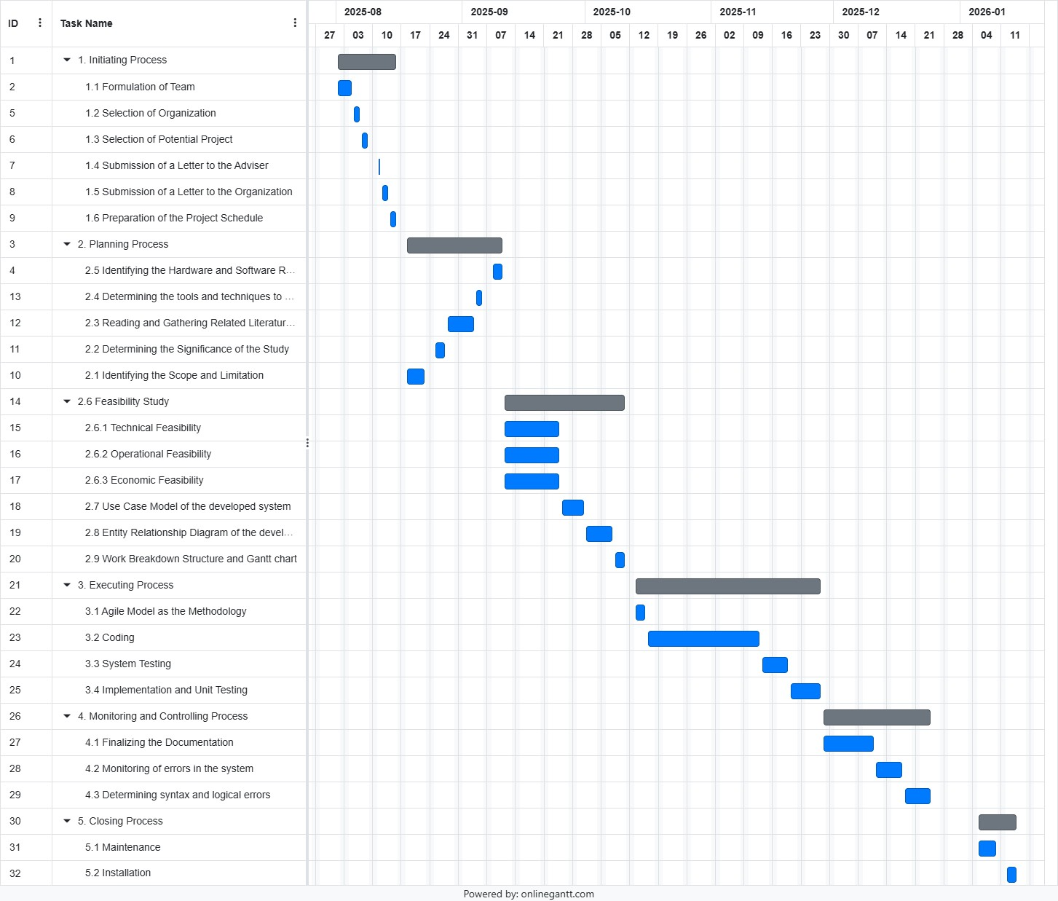

PROJECT MANAGEMENT
- Organizational Chart
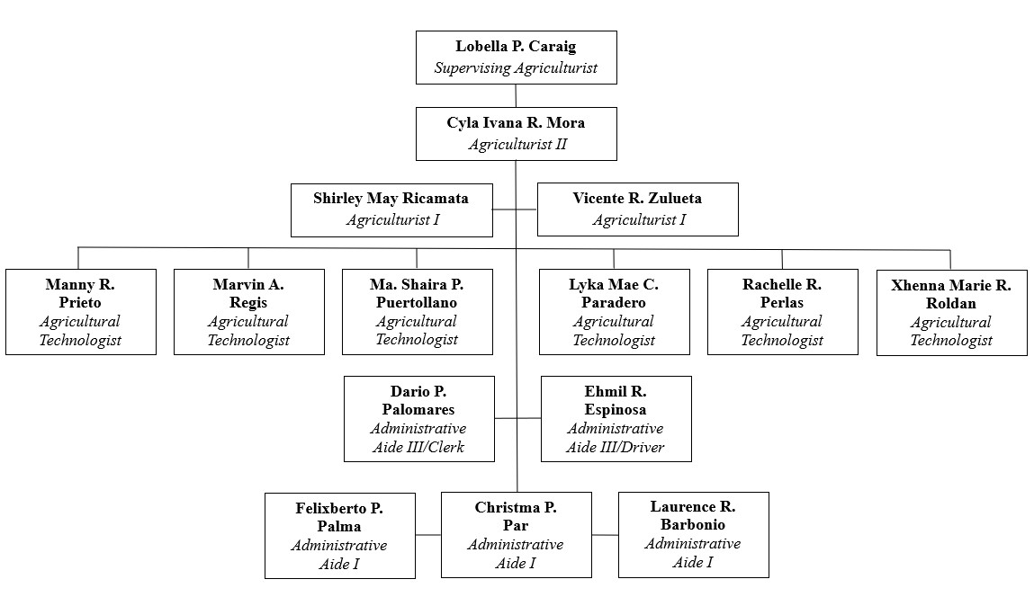

- Duties and Responsibilities
Designation | Duties and Responsibilities | Remarks
Supervising Agriculturist | Oversees agricultural programs, leads planning and implementation of projects, and supervises all staff under the  Municipal Agriculture Office. | Head of the office/section
Agriculturist II | Provides technical assistance to farmers, prepares agricultural reports, conducts field visits, and supports agricultural development programs. | Senior technical staff
Agriculturist I | Assists in implementing agricultural activities, monitors crops and livestock, and helps farmers with basic agricultural needs. | Entry-level technical support
Agricultural Technologists | Conducts field monitoring, assists in agricultural trainings, collects data from barangays, and helps implement agriculture-related programs. | Field-based staff
Administrative Aide III / Clerk | Handles office paperwork, files documents, assists in preparing reports, receives and processes forms, and performs clerical tasks. | Office clerical staff
Administrative Aide III / Driver | Drives office vehicles, transports staff and documents, assists during field activities, and ensures vehicle maintenance. | Provides transportation support
Administrative Aide I | Performs basic office tasks such as filing, assisting visitors, organizing documents, and supporting other staff when needed. | General office assistant

CHAPTER III METHODOLOGY

Requirements Gathering and Analysis
This section explains the steps used to gather the information needed for the Development of Pet Registration and Monitoring System for Municipal Agriculture Office in Santa Cruz, Marinduque.

Before the interview, a formal request letter and guide questions were prepared by the proponents to
ask permission to conduct an interview with the MAO staff. The interview was conducted with Agriculturist I, Mr. Vicente R. Zulueta, who provided details about the current process of handling pet registration, vaccination records, and monitoring activities in the municipality. During the interview, he also shared sample forms and documents used in their manual process. This helped the proponents understand the challenges of the existing system and identify what features were needed for improvement.

A Use Case Diagram was created to clearly show how the users interact with the proposed system and
what major functions are required. A Gantt Chart was also prepared to plan the schedule of activities, monitor progress, and ensure that each task is finished on time. These tools helped the proponents organize the gathered information and guide the development of the proposed system.

Feasibility Analysis Procedure

Economic Feasibility
Equipment Used in Operation | Estimated Price | Description
Laptop | ₱35,000 | Used to run the system and encode pet information.
Printer | ₱7,000 | Used to print pet records and reports.
Bond Paper / Printable Forms | ₱250 per ream | Used for printed documents.
Internet Connection | ₱1,500 per month | Used for basic system updates and communication.

Technical Feasibility
SWOT ANALYSIS FOR TECHNICAL FEASIBILITY
STRENGTH  - The developers know basic computer and coding skills.  - The developers work well together as a team.  - The developers can learn fast when guided.  - The developers have ideas on how to design simple systems. | WEAKNESS  - Limited experience in building full systems.  - Sometimes have difficulty managing time.  - Need better computers or tools for development.  - Not fully familiar with some advanced software.
OPPORTUNITIES  - Strengthen and widen the knowledge in different programming languages.  - A chance to work on an organization to continue on developing the system and further improving it and for maintenance and update. | THREATS  - Possible power interruptions while working.  - Unstable internet connection.  - Unexpected technical problems like laptop issues.

Operational Feasibility
SWOT ANALYSIS FOR OPERATIONAL FEASIBILITY
STRENGTH  - Staff are familiar with pet registration and agriculture-related tasks.  - The office has clear procedures for handling records and reports.  - Employees have experience working directly with residents and barangays. | WEAKNESS  - Delay in accessing information due to physical record-keeping.  - Some processes are still done manually, which slows down operations.  - Communication with barangays and residents is sometimes slow.
OPPORTUNITIES  - Support from the LGU can help improve office operations.  - Training programs can enhance staff skills in record management and services.  - Better coordination with barangays can improve service delivery. | THREATS  - Unstable power or internet connection may affect daily operations.  - Increase in workload during peak seasons may slow down services.  - Weather disturbances may disrupt field activities and office schedules.

Development Procedure

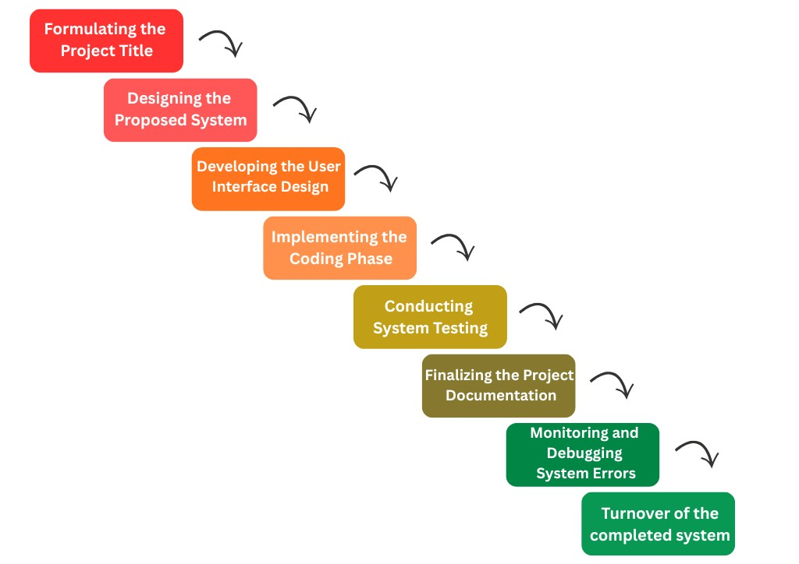

Figure 1. Waterfall Development Model

Operation and Testing Procedures

Operation Procedure
- Open the system and log in using your username and password.
- Go to the dashboard to see an overview of registered pets and updates.
- Click the Pet Registration page to add new pets and owner information.
- Upload needed files like the pet’s photo and vaccination record.
- Save the form and check if the new pet appears on the list.
- Use the Monitoring page to view pet health, vaccination schedules, and status.
- Update pet records whenever there are new health or vaccination details.
- Create reports such as pet population or vaccination lists when needed.
- Review system activity to make sure all records are updated and correct.
- Log out after using the system to keep information safe.

Testing Procedure
- Test if all main features work properly including login, register pet, monitor pets, create reports.
- Check if the layout is clear such as buttons, labels, and pages should be easy to use.
- Try entering wrong or incomplete information to see if the system gives warnings.
- Make sure the database saves, updates, and deletes records correctly.
- Test the search and filter tools to see if they quickly find the right records.
- Check the security features like password rules and user access limits.
- Test how fast the system loads and responds when used.
- Try opening the system on different devices and web browsers.
- Check if the system works smoothly even when the internet connection is slow.
- Write down all results, find the problems, and suggest improvements before the final release.

Evaluation Procedure
The evaluation of the Pet Registration and Monitoring System will be done to determine its usability,
accuracy, performance, and overall acceptability. The system will undergo preliminary evaluation to check if its major features are working correctly, followed by performance evaluation based on basic software quality standards such as ease of use, reliability, speed, and accuracy. To measure user satisfaction, a survey questionnaire using a 5-point Likert scale will be given to selected evaluators, which include Municipal Agriculture Office staff and IT experts. Evaluators will be chosen based on their involvement in pet registration tasks or their expertise in system development. A sample of 5 to 10 MAO staff and 1 to 3 IT experts will test the system by performing tasks such as login, registration, monitoring, and report generation. After using the system, they will answer the questionnaire, and the collected data will be summarized and analyzed using mean and weighted mean to determine the system’s level of acceptability. The results will help identify areas for improvement before the system’s full implementation.

Implementation Plan
The implementation of the Pet Registration and Monitoring System will be carried out in a step-by-
step process to ensure that the Pet owners and the Municipal Agriculture Office in Santa Cruz, Marinduque can easily adopt and use the system. The project will begin with proposing the working title of the project to formally identify its purpose and scope. After this, a questionnaire will be created and reviewed to ensure that it properly measures the needs and expectations of the Municipal Agriculture Office. The survey will then be conducted among the selected respondents to gather important data that will guide the development of the system. Once the data is collected and analyzed, the design and development of the system will follow, including creating the interface and core features. After the system is built, it will undergo system deployment, user orientation, and initial testing to make sure it works correctly. Feedback from testing will be used to make improvements until the system becomes ready for full deployment. Throughout the process, the project team, IT developers, and MAO staff will work together to ensure that the system is smoothly implemented and effectively supports the office’s operations.

Development of Pet Registration and
Monitoring System for Municipal Agriculture Office in Santa Cruz, Marinduque

Proponents
RUBY CHARLENE R. PERILLA
DAD’S CHARLOTTE DG. PRIVADO

December 2025

